Executive Summary: work must start now
In Aotearoa, the Government has committed to reaching net zero emissions of long-lived gases by 2050, and to reducing biogenic methane emissions by between 24-47% by 2050.
The work that He Pou a Rangi, the Climate Change Commission, has carried out over the last year shows that meeting these targets is possible – and can lead to a thriving, climate-resilient and low emissions Aotearoa.
Transformational and lasting change across society and the economy will be needed, but the Commission’s analysis shows the tools to start the work to reach our targets and address climate change in Aotearoa already exist.
To meet the Commission's proposed emissions budgets, Aotearoa does not need to rely on future technologies. As new technologies develop, this will allow the country to reduce emissions even faster.
However, the Government must pick up the pace. Aotearoa will not meet its targets without strong and decisive action now to drive low emissions technologies and behaviour change across all sectors. 2050 is not far away – particularly if you consider the life span of infrastructure, vehicles, buildings – and people.
Aotearoa must focus on decarbonising and reducing emissions at the source. As a country we can no longer rely on forests to meet our climate change targets.
Current government policies do not put Aotearoa on track to meet our recommended emissions budgets and the 2050 targets.
In 2018, gross greenhouse gas emissions in Aotearoa were about 45.5 Mt CO₂₋e of long-lived gases, and 1.34 Mt CH₄ (biogenic methane). Our analysis shows if policy stayed as it is now, Aotearoa would fall short of achieving the 2050 net zero long-lived gas target by 6.3 Mt CO₂₋e. Biogenic methane would reduce 12% below 2017 levels and fall short of the current target of 24-47%.
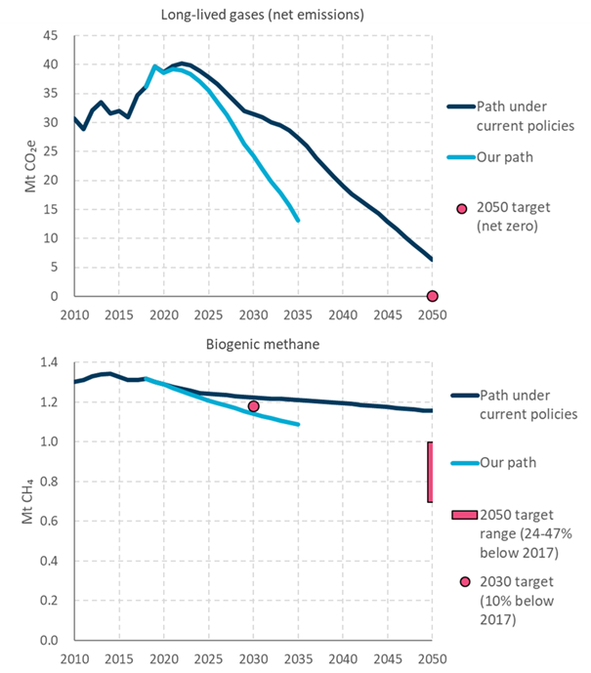
Figure ES1: Current government policies do not put Aotearoa on track to meet the Commission’s emissions budgets and the 2050 targets. This figure shows how our path to 2035 would reduce emissions of long-lived gases (top figure) and biogenic methane (bottom figure)
The Emissions Trading Scheme (NZ ETS) alone won’t get us to where we need to be. Action is needed across all sectors of the economy.
Priority areas for action include increasing the number of electric vehicles on our roads, increasing our total renewable energy, improving farm practices and planting more native trees to provide a long-term carbon sink.
Care should be taken to make sure climate related policies do not further compound historic grievances for Māori. To give effect to the Treaty Partnership, central and local government need to acknowledge iwi/Māori rights to exercise rangatiratanga and kaitiakitanga in a joint plan to reduce emissions.
The speed of this transition needs to be steady – fast enough to make a difference and build momentum but considered, with room to support people through the change. An equitable transition means making sure the benefits of climate action are shared across society, and that the costs of the climate transition do not fall unfairly on certain groups or people.
To achieve this, we need to understand that all things are connected: the people, the land, the atmosphere, the oceans. This connectivity – material and non-material – is central to Te Ao Māori. It is also essential to understanding how to guide a transition that is fair and equitable for people and the environment.
The transition must reduce emissions at pace while allowing the country to continue to grow, so that future generations inherit a thriving, climate-resilient and low emissions Aotearoa.

Our first package of advice
This advice provides Aotearoa with a comprehensive strategy for tackling climate change. It is also the starting point. It outlines the first in a series of steps that chart the course for reducing emissions.
We asked ourselves a series of questions when developing this advice. They are: Is this ambitious enough? Is it fair and equitable? Is it technically and economically feasible? And, can it be achieved through policy?
We have used a range of quantitative and qualitative tools, including economic models and analytical frameworks. Our analytical approach used the He Ara Waiora framework to understanding wellbeing from a mātauranga Māori perspective and form an anchor for our analysis.
Our advice includes recommendations on the level of the first three emissions budgets. It also provides advice on strategic policy direction for meeting the emissions budgets, looking at what’s needed across different sectors. We recommend 17 critical actions the Government must take to reach its climate goals.
Many recommendations include indicators the Commission will use to monitor the Government’s progress.
In developing our advice, we focused on key sectors across the economy, identifying where the greatest opportunities to reduce emissions are, and working with experts and stakeholders to understand the barriers for change. Some key findings from these sectors include:

Land
- Agriculture has a large role to play in reducing emissions, and farming needs to become even more efficient. There have been improvements in the last few decades, but more can happen.
- Aotearoa has been an agricultural world leader over recent decades. We must adapt and improve our use of our land to keep this status. This means developing, adopting and using practices and technologies that lower emissions and address climate change.
- Forests have a role to play, but we can’t plant our way out of climate change.

What are we recommending?
- The Government needs a cohesive strategy that includes water, biodiversity and climate. There are multiple benefits to taking a holistic view of how we use and protect our land.
- There are changes farmers can make now to reduce emissions on their farms while maintaining, or even improving, productivity. This includes reducing animal numbers and better animal, pasture and feed management. Policy support is needed to make this happen.
- Our advice advocates for a long-term plan for targeted research and development of new technologies to reduce emissions from agriculture.
- Pine trees will still play an important role in getting to 2050 and could support a future bioeconomy, as bioenergy to replace fossil fuels and as timber for building.
- Existing forests, small blocks of trees, soils and wetlands can all store more carbon. Work is needed to better understand this potential and how to include this in accounting systems.
- Native forests can create a long-term carbon sink while providing a range of other benefits, like improving biodiversity and erosion control. Incentives are needed to get more native trees planted.

Agriculture
What is the sector’s current emissions profile?
In 2018, agriculture emissions made up about 90% of biogenic methane and 18% of long-lived gas emissions. This is 1.2 Mt CH₄ and 8.3 Mt CO₂-e, respectively.
Where does this come from?
Long-lived gases from agriculture are largely nitrous oxide, coming from animal urine and synthetic fertiliser use. Smaller amounts of carbon dioxide are emitted through other types of fertiliser.
Biogenic methane emissions from agriculture are primarily from deer, sheep, beef and dairy cow burps.
What does our path show for this sector?
By 2035, our path shows that biogenic methane emissions from agriculture reduce to 0.97 Mt CH_{4,} and long-lived gases reach 6.9 Mt CO₂-e. This puts us on track to meeting our 2050 target.

Forestry
What is the sector’s current emissions profile?
In 2018, forests removed 9.5 Mt CO₂ from the atmosphere. Our emissions would be 14% higher without this.
Where does this come from?
Forests remove carbon dioxide from the atmosphere as they grow and emit it when they burn or decompose after harvest or clearance.
What does our path show for this sector?
By 2035, our path shows that net forestry removals reach 14.5 Mt CO₂. This puts us on track to meeting our 2050 target.

Waste
- Aotearoa needs to fundamentally change the way it deals with and thinks about waste. A transformation to this sector will not only reduce emissions but move us from a throw away culture to one that values our resources.

What are we recommending?
- Creating a circular, self-sustaining economy will reduce Aotearoa’s waste emissions and cut biogenic methane emissions. Strengthened product stewardship and a commitment to resource recovery and reuse must be part of this approach.
- Capturing methane from any remaining waste that makes it to landfill will further emissions reduction.

Waste and F-Gases
What is the sector’s current emissions profile?
In 2018, waste emissions made up 10% of total biogenic methane. This is 0.14 Mt CH_{4.} The sector also emitted 0.22 Mt CO₂-e of long-lived gases. Emissions of hydrofluorocarbons (HFCs) were 1.8 Mt CO₂-e.
Where does this come from?
Most waste emissions are from solid waste decomposing at landfill (90%), with smaller portions from wastewater treatment (9%) and burning and composting emissions (1%). F-gas emissions are largely from the leakage of HFCs used in refrigeration and air conditioning systems.
What does our path show for this sector?
By 2035, our path shows waste emissions reduce to 0.12 Mt of biogenic methane. HFC emissions reduce to 1.2 Mt CO₂-e.

Transport
- Reducing transport emissions is crucial to meeting our climate targets. Action here will have an immediate and lasting impact. Aotearoa can cut almost all transport emissions by 2050. The technology already exists and is improving fast.
- In Aotearoa we need to change the way we build and plan our towns and cities and the way people and products move around. This includes making walking and cycling easier with good cycleways and footpaths. It means moving freight off the road and onto rail and shipping. It means reliable and affordable public and shared transport systems. And it means an electric or low emissions transport fleet.

What are we recommending?
- An integrated national transport network should be developed to reduce travel by private car. There needs to be much more walking, cycling and use of public and shared transport.
Transport
What is the sector’s current emissions profile?
In 2018, transport emissions made up 36.3% of total long-lived gases. This is 16.6 Mt CO₂-e.
Where does this come from?
Most transport emissions are from fossil fuels used to power vehicles. For example, petrol and diesel used by cars, SUVs and trucks (91%), domestic flights (7%) and rail and coastal shipping (2%).
What does our path show for this sector?
By 2035, our path shows transport emissions reduce to 8.8 Mt CO₂-e. This puts us on track to meet our 2050 target.
- Electric vehicles are key and need to be widely adopted. We want to see the majority of the vehicles coming into New Zealand for everyday use electric by 2035. The government will need to provide support and incentives to make this happen.
- Use of low carbon fuels, such as biofuels and hydrogen, needs to increase, particularly in heavy trucks, trains, planes, and ships.

Heat, industry and power
- Aotearoa needs to decarbonise how we produce and use energy. We need to move towards a set of diverse and low emission energy sources by 2050.
- Aotearoa will need to maximise the use of electricity. This means generating and using more low emissions electricity for vehicles and for process heat. Building more renewable generation such as wind, solar and geothermal will be required.
- Reducing emissions from process heat is key. Other low emission energy sources, such as bioenergy, will be needed.
- Emissions must be reduced at pace while allowing the country to continue to grow. Planning ahead so that technologies, assets and infrastructure can be replaced with low emissions choices on as natural a cycle as possible will help business and industry keep pace with the transition.

What are we recommending?
- We need to almost eliminate fossil fuels. This means ending the use of coal.
- The homes, buildings and infrastructure we build now will still be here in 2050. We need to think about our choices with climate change in mind. That means using low emissions technologies and prioritising energy efficiency.
- In the long-term, we will need to reduce how much natural gas we use in homes and businesses.

Heat, Industry and Power
What is the sector’s current emissions profile?
In 2018, heat, industry and power emissions made up 41% of total long-lived gases. This is 18.8 Mt CO₂-e.
Where does this come from?
Heat, industry and power emissions come from using fossil fuels, such as coal and gas, to generate electricity (22%); producing heat and chemical reactions to manufacture products (47%); fossil fuels used in our buildings and homes (7%); oil refining, oil and natural gas production and the operation of coal mines (12%); and the use of off-road vehicles and machinery (11%).
What does our path show for this sector?
By 2035, our path shows emissions from heat, industry and power reduce to 10.4 Mt CO₂-e. This puts us on track to meet our 2050 target.

Emissions budgets
We have proposed the first three emissions budgets for Aotearoa. These budgets set the maximum amount of greenhouse gases Aotearoa can emit over a five-year period and chart the course for stepping down emissions.
We have looked at opportunities and barriers for reducing emissions across the whole economy. The budgets are based on how far and how fast our analysis tells us Aotearoa can go towards the 2050 targets.
Our recommended budgets are consistent with putting Aotearoa on track to meeting the 2050 target under a wide range of future circumstances.
The budgets are ambitious, but achievable. They represent a significant reduction on current levels of emissions, and step down considerably over time.
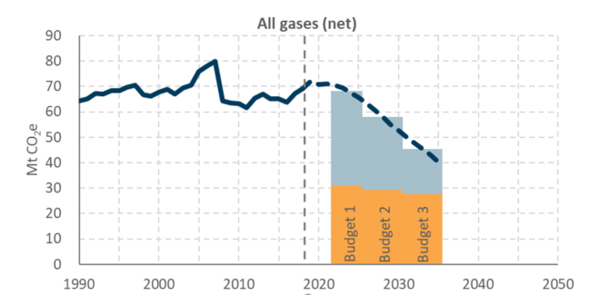
Figure ES1: Our proposed emissions budgets. The figure shows all gases combined as CO₂ equivalent – grey is emissions of long-lived gases, orange is biogenic methane emissions.
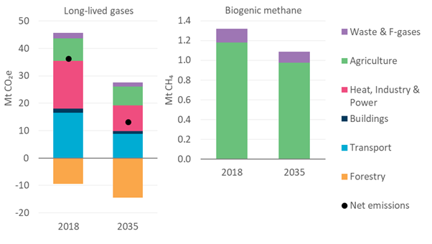
Figure ES2: How our path would reduce emissions across all sectors by 2035. Note that long-lived gases from agriculture are mainly nitrous oxide and some carbon dioxide.
Table ES1: Our proposed emissions budgets. All gases are combined as CO₂ equivalent
 | 2018 | Emissions  budget 1  (2022 – 2025) | Emissions  budget 2  (2026 – 2030) | Emissions  budget 3  (2031 – 2035)
All gases, net (AR4) (Mt CO₂e) |  | 271 | 286 | 223
Annual average (Mt CO₂e/year) | 69.2 | 67.7 | 57.3 | 44.6
Average reductions on 2018 levels |  | 2% | 17% | 36%
Each budget must be met, as far as possible, through reducing and removing emissions here in Aotearoa. Gross emissions must be reduced to meet and sustain the country’s emissions targets, and to avoid pushing the burden to future generations.
Relying heavily on forestry before 2050 is likely to make maintaining net zero long-lived greenhouse gas emissions after 2050 difficult. It would delay action, lead to higher cumulative emissions and make the job ahead of us more difficult.

How to meet the emissions budgets – direction of the emissions reduction plan
Meeting our proposed emissions budgets and 2050 targets requires transformational change across all sectors of the economy.
Our analysis shows that reducing transport emissions is crucial to meeting our emissions budgets and reaching net zero by 2050 – this will have an immediate and lasting impact.
This means changing the way we travel and move goods. New Zealanders should be able to walk and cycle more. Freight will need to come off the road and onto rail and shipping.
To lower emissions we will need to change the way we plan and build our cities to make it faster and easier to get around. Having an integrated public and shared transport system both locally and across Aotearoa will encourage a shift in the way we live and travel.
Our draft advice recommends action to drive change in all sectors, as described above. It also recommends changes that cut across sectors, to support behaviour change and make sure that climate change is factored into government decisions. Changes to the ETS are needed to make sure it drives low emissions choices. We also recommend measures to ensure policy decisions and investments made now do not lock Aotearoa into a high emissions path.

What will this mean for New Zealanders?
Aotearoa must have an equitable and fair transition to a low emissions economy and society with benefits widely shared.
We have looked at the impacts which our budgets could have on the economy and society over the next 15 years. The overall costs of meeting the country’s targets and our proposed emissions budgets are likely to be less than 1% of projected GDP. This is significantly lower than what was estimated when the 2050 targets were set. While the overall costs are small relative to the size of the whole economy, they will not be evenly felt.
The transition to a low emissions society will bring opportunities, benefits, challenges and costs. Any change needs to be well-signalled, equitable and inclusive to make sure that it maximises opportunities while minimising disruption and inequities.
Different groups of society, regions and sectors will be affected in different ways, and impacts won’t always be evenly distributed. The Government will need to address this through careful policy design and targeted support. At the same time, government will need to recognise and encourage the co-benefits that come from climate action. This includes health improvements, quieter streets, cleaner water and increased biodiversity through more native forests.
There will inevitably be changes to employment as Aotearoa moves to low emissions. The coal mining and oil and gas sectors, and the services that support them, will be impacted by the transition away from fossil fuels. This will particularly affect regions with lots of workers in these industries. While these industries are already declining, our proposed emissions budgets could speed this up and possibly result in 600-1,100 fewer jobs across both sectors by 2035.
It is worth noting that many of these workers have important skills that will be valuable in other sectors and new industries. We expect employment will rise in in the circular economy, development of biofuels and hydrogen, and in deploying and supporting new technologies. A well-signalled transition will allow time to plan and support workers to retrain and redeploy into new areas of work.
We recommend that the Government develop an Equitable Transitions Strategy to support an equitable, inclusive and well-planned climate transition.
Government will need to work alongside people, and ensure they are including young people, regional Aotearoa, low-income communities, some Māori and Pasifika and people with disabilities to make sure they benefit from the opportunities and are not disproportionately impacted.
Central and local government should support Māori communities to ensure they are appropriately resourced for the transition to a low emissions Aotearoa.
Government will need to co-develop plans to make this happen and recognise people are the experts – our communities know what actions need to be taken to benefit or empower them.
While some businesses will need to close there will be many opportunities for new industries, businesses and jobs. Our analysis suggests that our emissions budgets could result in job losses in the coal mining and oil and gas sectors. At the same time, taking action to meet the budgets is also likely to result in new jobs in other sectors and new industries, such as supporting and deploying new technologies.
The make-up of the economy will change, and some workers will need to be supported to retrain or move to similar jobs in new industries.

Reductions in biogenic methane
Current Aotearoa targets require biogenic methane emissions to reduce by 10% below 2017 levels by 2030 and between 24-47% by 2050.
The Commission has been asked to provide advice on how much biogenic methane emissions may need to be reduced by in the future for Aotearoa to meet its international obligations.
Our analysis shows that by 2100, Aotearoa could need to reduce methane emissions by 49-60% below 2017 levels.
Our country’s world-leading agricultural sector has made big advances over the last 60 years, and improvements can and should continue.
Our analysis for our emissions budgets shows Aotearoa can achieve methane reductions of 24% by 2050 without any technology developments, such as vaccines or inhibitors. It is likely these technologies will become available, and this would increase the speed and efficiency of reducing methane emissions.

Our Nationally Determined Contribution (NDC)
The Commission was asked to determine if the first NDC for Aotearoa is compatible with contributing to global efforts to limit global warming to 1.5°C above pre-industrial levels.
Our analysis has found that the Government’s commitment to reduce net emissions by an average of 30% from 2005 emissions levels over the 2021-2030 period is not compatible with global efforts.
If Aotearoa is to play its part as a developed nation, the NDC would need to be strengthened to reflect emission reductions of much more than 35% below 2005 levels by 2030.
The Commission’s proposed emissions budgets are already ambitious – but the NDC goes further.
To achieve our NDC, Aotearoa will need some offshore mitigation. We are not using this to do less domestically – but to increase our contribution beyond what is possible at home.

Conclusion
This document contains the Commission’s first draft advice to government, for input and consideration by the people of Aotearoa.
The advice and recommendations contained in this report draw on robust evidence and expert analysis. It incorporates knowledge and wisdom from a wide range of people and organisations to ensure it is sound and reflects our diverse experiences.
But this is draft advice. We are committed to true consultation and want to hear your feedback. We will consider all evidence we receive during consultation and are prepared to review and change any part of our work in light of this. We need to achieve a plan to address climate change that is effective, considered and ambitious – and Aotearoa won’t get there unless we work together.

