A Transport Strategy for New Zealand
Why do we need a transport strategy?
Benjamin Franklin said “if you fail to plan, you plan to fail” and Henry Ford made the statement “if you always do what you’ve always done, you will always get what you’ve always got”
It turns out they were right. We have demonstrated time and time again that predict and provide in the transport network does not work. By the time we have provided what we predicted, it is too late to accommodate the growth. Our planning is too short-term and reactive.
New Zealand keeps building more and more infrastructure to service the needs of an ever growing population that is dependent on motor cars. We end up with a road based transport system that is predominantly designed to just cope for two hours a day and then be hugely oversupplied for the remaining twenty-two. We now need a huge amount of land in our urban centres to abandon these vehicles for 8 hours a day and then have them resort to asphalt deserts at night. A quick look at Google Earth suggests this could be up to 30% of the extremely valuable CBD real estate.
An overarching transport strategy or at least a strategic vision agreed upon by all political parties would enable a best for New Zealand investment strategy. Over any particular three year term, the government would be prioritising elements of a larger whole rather than changing the direction.
Future State 2050
In order to understand our future investment needs, we need to define a future state we are working to. The Ministry of Transport has postulated scenarios for the future of transport over the next two decades, from which we can distil two very different futures:
Business as Usual Where we continue to develop and expand road-based transport based on private ownership. With limited uptake of AVs and low PT usage. EVs will become mainstream to counter rising fossil fuel prices. People will still value their mobility “independence” ahead of environmental or congestion costs. Investment will be forced into ‘predict and provide’ with ‘reactive’ introduction of measures to combat rising transport inefficiencies and erosion of safety standards.
Sustainable Lead Where there is a shift to mass transit in the urban centres to avoid wasting productive and personal time in traffic congestion. EVs are mainstream in private vehicle ownership and within public fleets to counter fuel cost rises and improve emissions in urban areas. Walking and cycling dominate residential and CBD areas. People will continue actively seek to reduce the time to reach a destination unless it is part of a fitness or recreational activity.
In both scenarios the uptake of automated vehicles (AVs) is limited until the technology becomes proven and failsafe. It is assumed that certain modes will lead the AV market such as public transport and some commercial road freight activities, most likely interregional where the actual decision making is less onerous.
New Zealand needs to replace business as usual by a strategic shift to pursue, a more sustainable and people friendly outcome by 2050.
Targets
The Government has set a target of reducing carbon emissions to net zero by 2050. This is in accordance with international scientific evidence that global emissions will need to reduce by that amount if the world is to achieve the target set in the Paris Agreement of 15th December 2015 of limiting global warming to no more that 2ºC above pre-industrial levels, and to “the intent to pursue a 1.5ºC target”. New Zealand’s net greenhouse gas emissions have increased by 54% since 1990, so the growth curve will have to be turned sharply down to achieve a target of net zero by 2050.
Transport emissions amount to 18.4% of the cumulative percentage of gross emissions in New Zealand, and replacing combustion of fossil fuels with clean alternatives (e.g. electric vehicles) is identified as one of the three key drivers of emissions reductions by the Productivity Commission
New Zealand should adopt a set of aspirational targets for transport and actively seek to achieve them through successive governments and across public and private sectors.
Target 1: Urban Centre Mode Share
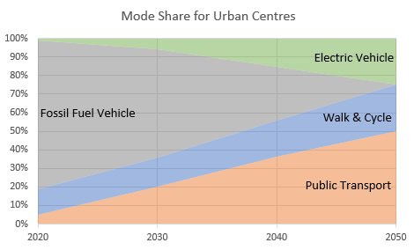
Public transport (including: bus, BRT, LRT, and heavy rail) should provide the primary means of transport within our urban areas, it is not impossible to expect 50% of commuter trips to be made by public transport in 2050. This will also catalyse a change in development intensity and should result in more people living closer to where their destinations increasing walking and cycling to 25%. Private transport will still play a role but will be significantly lower than its current dominant position at 25% of trips.
Public transport 50%, active transport 25%, private vehicle25%

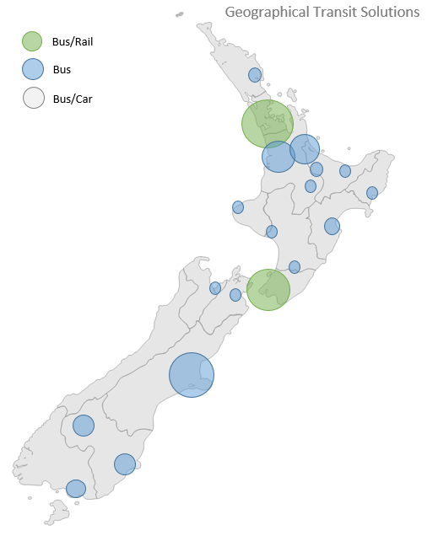
Target 2: Regional Transport
The role of private vehicles should diminish as the need to commute and carry out daily activities is taken up by other modes and through changes in our urban landscapes. Moving between centres will require a different approach. Regional rail will serve more densely populated regions, such as the Upper North Island and around Wellington and Hawkes Bay More remote areas will still need longer distance bus services and private vehicles will still play a role.

Public transport 50%, private vehicle 50%
Target 3: Inter-Regional Transport
Long distance travel will continue to rely on domestic air schedules, although with increasing fuel costs this may not be financially viable unless speed is essential. Alternative aircraft fuels or battery technology may change this escalation in future cost. Interregional passenger rail could be possible with significant investment in infrastructure and rolling stock, although the dream of high speed rail linking Auckland to Wellington may be several decades away. Long distance bus travel will still play a role, particularly for tourism, and this is another area which can be improved through autonomous or semi-autonomous technology. Once again the private car will be a backstop for ad hoc long distance travel, touring and many recreational activities.
Air travel 5%, public transport 20%, and private vehicles 75%
Target 4: Freight
It is essential for our economy to maintain efficient and resilient freight transport, this will continue to rely on road freight and rail to access our ports. The key drivers will need to be environmental and reliability. Fundamentally, the use of electric motive power should be considered to be the benchmark in our future rail infrastructure.
The North Island Main Trunk (NIMT) railway is currently electrified only between Te Rapa and Palmerston North. Full electrification of the NIMT railway should therefore be a medium to long term goal. The first stage of completion could be Papakura to Hamilton and Tauranga. A subsequent stage could be from Palmerstion North to Wellington. The current proposal to decommission the electric locomotives, and replace them with diesel would appear to be a retrograde step, with immediate consequences of increased carbon emissions and potentially prejudicing long term completion of electrification of the NIMT.
Conversion of the road fleet to biofuel or electric power will be a priority to reduce harmful emissions. The parallel evolution of public transport should relieve the congestion in the first and last mile of freight trips although physical and temporal segregation may also be beneficial, particularly if we are to employ autonomous technology to improve safety and efficiency. Night time deliveries by autonomous electric trucks. The reliability of freight can be optimised through connected technology and rapid transition between road, rail and sea. Provision of freight only lanes and moving major installations (ports, major manufacturing etc) away from congested urban routes could be beneficial and would allow redevelopment of prime city centre real estate.
Zero carbon by 2050: Road freight fleet fuel fully converted, 100% rail electrification
Target 5: Active Transport
Walking and cycling requires the least road space, but both modes are vulnerable to accident and injury. The counterpoint to this is that walking and cycling are cheap and generate no pollution as well as offer significant health benefits to participants. The proportion of road space suitable for walking and cycling needs to increase in urban areas to accommodate and attract more active transport.
Urban intensification and the shift to transport modes away from private vehicles will drive the change, as will technological advances which will permit less able or less confident people to participate in more active lifestyles, such as the significant rise in electric bike usage which make cycling more accessible with longer distances and negotiating hills much easier for all levels of fitness.
25%+ active transport in urban areas

How do we achieve a better, more sustainable transport future?
To have a chance of meeting climate change and emissions targets we need to phase out the use of fossil fuels as the primary source of motive power for all modes. Carbon free land transport by 2050 (in line with other international aspirations) is wholly achievable with the right investment from the outset:
- Biofuels can be used in most diesel engines with relative ease, this can replace the worst polluting 18% of the vehicle fleet, as well as providing a way of retaining commercial fleets and inter regional rail freight in the medium term.
- Electric vehicle technology is improving year on year and the baseline prediction for light vehicle fleet composition is 40% by 2040. Whilst capital cost is still a major factor in the decision to purchase an EV, this is offset by significant savings in running costs and will continue to normalise towards the that of traditionally fuelled vehicles as the number of vehicles grows and public trust in the battery technology is realised. With a high proportion of EVs, charging facilities will need to be commonplace. However, to achieve a fully carbon neutral transport system by 2050, significant efforts will be needed, along with legislation along the lines of the European ban on sales of new fossil fuel vehicles in 2025.
- Data and communication technology needs to be cohesive and adaptive. We need to be better connected in the future to allow for vehicle to vehicle and infrastructure to vehicle communication that is synonymous with all future transport technologies. This will have an added benefit of allowing full CCTV and communications coverage of our transport corridors allowing instant feedback on problems and emergencies, allowing rapid deployment of rescue services and redirection of traffic. A single, or at least a wholly compatible, mobile information system is needed that will link mobile devices and enabled vehicles to communicate in real time with central data sources as well as maintain contact with local systems.
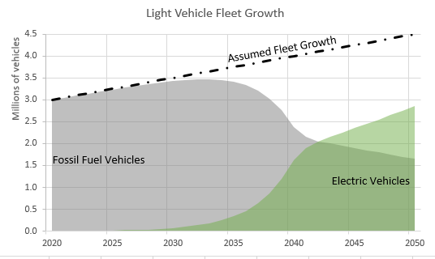
- Private vehicles will still play a role in the transport task, particularly in rural areas where it is less viable to provide public transport, and in longer journeys to places and at times where PT is simply not viable. To remove the need to accommodate mass movement of private cars from outer suburbs and rural areas we should invest in park and ride at the start of the regular public transport routes. Those who choose to drive to the CBD for work purposes will have to pay a premium for car parking, although shoppers should not be discouraged if they need to drive to make purchases and use the roads outside of main commute times. With a high proportion of EVs, charging facilities will need to be commonplace.
The above graph represents the expected organic growth in EVs and subsequent decline in fossil fuel vehicles within the NZ fleet. There is still an underlying trend towards private vehicle ownership as depicted in the fleet growth. Without a step change in legislation we will not be able to realise our vision of a carbon neutral transport system in 2050. Similarly, without some other intervention, we are likely to see a 50% increase in private vehicles on our roads in the same time. The introduction of more widespread ridesharing, Uber and other hail services, mass transit, and autonomous vehicles will all play a role in reducing the need for car ownership, or at least the need to commute in a single occupancy vehicle.
Public Transport
Public transport and mass transit should dominate the urban centres to provide a real alternative to private cars on a day to day basis for commuting and the ubiquitous school run. In order for this mode to be a real viable alternative it must be reliable, faster and of equal quality to private vehicles. This will require:
- Continuous transit lanes or bus only streets with queue jump ability at key intersections;
- High quality vehicles with features such as Wi-Fi, USB charging and news channels, etc;
- Service routes and schedules that meet the needs of the people who will use them;
- Quality infrastructure at either end of the trip with covered waiting areas, good personal security, seating, toilets etc at key locations;
- Quality real time information and mobile applications that allow route planning and permit quick variance if circumstances change;
- Service resilience with the ability to cope with weather events and other crises without shutting down and stranding users.
Reclaiming or urban centres
The widespread use of PT will reduce the need to use valuable real estate for the parking of vehicles. Currently something like 25-30% of our urban centres are given over to car parking. Removal of the need to drive a car to work will allow the repurposing of these wasted areas into public green spaces, commercial premises and urban apartments which will increase the economic worth of our towns and cities and improve their liveability.
Streets can become people focussed, currently more than 80% of our urban corridors is provided for the benefit of 20% of the people travelling along them. Frequently there is no need for large volumes of through traffic to share a corridor on something like a busy shopping street. The main purpose of the street is to provide access to shops, so why are the shoppers and workers crammed onto two ribbons of concrete? Urban intensification will also introduce more people into the urban centres rather than pushing them further and further out into remote suburbs. This in turn should be coupled with the provision of the majority of activities and services that people demand: recreational areas, green spaces, cafes, grocery stores etc. This removes the need to make regular trips by private vehicle and optimises the urban form towards walking, cycling and public transport.
Funding the Future State
Traditional taxation methods will decline as new technologies take hold. Current vehicle licensing and road user charging will produce less revenue as exempt or discounted fees attract more drivers away from traditional fossil fuels to hybrids, EVs and biofuels. Regional fuel taxes will provide a significant income from private vehicles and commercial fleets in the short term. However, this income will reduce over time as commuters shift to alternative fuels, car-pooling and public transport. Eventually the make-up of the fleet will change and we will need to look at alternative funding methods for transport investment.
In order to fund our transport network, we will have to devise a fair set of metrics in which the user is charged equitably. Fare box recovery mechanisms do not appear to work under the current public transport funding model. Mobility as a service is widely considered to be away forward in developing a fully integrated and accessible transport system for all. However, the price point should be such that it does not force people back into cars because of a perceived affordability.
The purpose of charging is to reduce demand. Congestion taxation is highly effective overseas as a key method of reducing single occupancy vehicles for the urban commute. Congestion charges can be targeted to reduce peak travel demand. Parking changes are the best mechanism to reduce demand in the short term. Restricting the supply of parking is a useful lever to reduce congestion and to increase safety in the crowded urban space.
Urban uplift and releasing valuable urban land for other issues are benefits that can be costed. Some costs can passed on to developers and property owners in the areas of benefit.
Funding Safety
The cost of road injuries in NZ accounts for 14% of ACC annual budget (or $450m per year), the anticipated investment in road safety improvements is approximately $900m per year with no significant turnaround in deaths and serious injuries for the last few years. In Canada, insurance companies fund road safety improvements in key locations and jurisdictions to reduce their liabilities for paying out in the event of a crash, this appears to be very successful. If ACC were to fund some improvements at a lower level, such as footpath and cycleway upgrades, not only would they be reducing the burden of road trauma for those modes, they would also be making them more attractive, increasing public activity and contributing to a wholesale improvement in health and fitness. A similar story can be told for public heath surrounding the non-trauma impacts of motor vehicles, in particular pollution which is suggested to cause as many deaths per year as road accidents.
Funding Transit
Mass transit corridors are known to be the catalyst of urban regeneration and economic gains within their sphere of influence, this is recognised by NZ Super Fund with their proposal to fund the Auckland Light Rail for a return on the future profits. This business proposition could be leveraged elsewhere with the improvement in land values and the increased need for high density housing within 1km of mass transit nodes. The opportunity exists for local government and developers to work with land owners to alter the spatial framework of our urban areas to facilitate this change.
There is a funding opportunity known as ‘value uplift captue’ commonly used in places like London, Hong Kong and many cities in USA. Property owners adjacent to rail and light rail, and particularly in the vicinity of stations, experience a substantial winfdall gain through uplift in their property values which is attributable to the new infrastructure. In a New Zealand context, part of this uplift in value could be captured by a targeted rate on properties that receive the benefits, and directed into further funding of the infrastructure. The Productivity Commission recommended legislative provisions to allow this new funding tool be considered.
Mobility as a Service is a possible way of opening public transport of all modes in all locations to all people through a rates based subscriber system, so in effect, everyone pays for the PT whether they use it or not, actual day to day travel in the urban area would be free and accessed through a card based or cell phone based identification system. This could be extended to park and ride for those commuters outside the urban area who do not want to pay for parking or for CBD access. The argument that you do not use PT is moot as you are paying for other people to use the bus, thereby making your car trip less congested.
Inclusive Mobility
No one should be excluded or disadvantaged by out transport strategies.
In 2013, 24% of the NZ population had some form of impairment, 18% of all adults are physically impaired in some way either through loss of senses or decreased mobility.
Based on Stats NZ population projections, and the proportion of our aging population, we are likely to see this rise to 24% in the next three decades, which could amount to 2.1 million people.
We cannot ignore the needs of a quarter of the population. Our built environment and transport systems must be designed or adapted to include every New Zealander.
This should include requirements for accessibility for all public places and modes of transport; better designed and maintained public spaces and paths; adaptable seating arrangements for mass transit; flush platforms for all forms of PT; better information and technologies to assist people who have some form of impairment.

Ministry of Transport (2017), Transport Outlook: Future State: A starting discussion on the future of transport in New Zealand
Ministry for the Environment (2018) , “New Zealand’s Greenhouse Gas Inventory”.
Productivity Commission of New Zealand (2018), Draft Report “Low Emissions Economy”.
Ministry of Transport (2016), New Zealand Fleet Annual Statistics
Tri State Transport Campaign (2018) – Road pricing in London, Stockholm and Singapore – A way forward for New York City
ACC Annual Report
American Public Transport Association (2014), Economic Impact of Public Transport Investment
Productivity Commission of New Zealand (2017), ‘Better Urban Planning’.
Stats NZ (2013), Disability Survey
Stats NZ (2017), National Population Estimates
Stats NZ (2016), National Population Predictions 2016 - 2068

