Call for evidence

We are calling for evidence on options available to reduce greenhouse gas emissions over the period 2022 to 2035.
Why are we doing this?
The Interim Climate Change Committee is the precursor to the proposed Climate Change Commission, expected to be established in late 2019 under the Zero Carbon Bill. The Bill provides a framework to help New Zealand deliver on the objectives of the Paris Agreement.
A key part of the proposed Commission’s work will be to advise the Government on emissions budgets.
Emissions budgets set the total emissions of all greenhouse gases permitted in the relevant budget period. The Government will set emissions budgets based on the proposed Commission’s advice.
Why are we doing this now?
We are running this call for evidence now as foundation work for the proposed Climate Change Commission to enable it to start work immediately as soon as it is set up.
It will help identify relevant information for developing these emissions budgets, and to maintain a broad, robust and transparent approach in developing the proposed Commission’s evidence base.
We have been asked to do this through our Terms of Reference. This work is also outlined in our letter to the Minister for Climate Change on 7 May 2019 here.
What are we looking for?
We are looking for high-quality, credible, evidence that will support the proposed Commission’s work on emissions budgets. This is likely to include knowledge and evidence of technologies and options to reduce emissions, and the economic, environmental, cultural and social impacts of them. We are not looking for personal views or opinions.
What if I have already made submissions on similar topics?
If you have already submitted evidence as part of consultation run by Government agencies, such as the Zero Carbon Bill or the Ministry of Transport’s Clean Car Standard and Discount, then we are happy for you to point us to those submissions, noting the key information or material that relates to our call for evidence.
What will we do with the evidence we gather?
We will use this information to inform our initial work on emissions budgets and add to the evidence base the proposed Commission will draw upon.
Confidentiality and data protection
All or part of any written response (including the names of respondents) may be published on our website www.iccc.mfe.govt.nz. Unless you clearly specify otherwise, we will consider that you have consented to both your name and response being published.
Please be aware that any responses may be captured by the Official Information Act 1982. Please advise us if you have any objection to the release of any information contained in your response, including commercially sensitive information, and in particular which part(s) you consider should be withheld, together with the reason(s) for withholding the information. We will take into account all such objections when responding to requests for copies of, and information on, responses to this document under the Official Information Act.
The Privacy Act 1993 applies certain principles about the collection, use and disclosure of information about individuals by various agencies, including the Interim Climate Change Committee. It governs access by individuals to information about themselves held by agencies. Any personal information you supply to the Committee in the course of making a response will be used by the Committee only in relation to the matters covered by this document. Please clearly indicate in your response if you do not wish your name to be included in any summary of responses that the Committee may publish.

Call for evidence: response form
We are looking for responses that are evidence-based, with data and references included where possible. Please limit your response to each question to a maximum of 400 words, plus links to supporting evidence, using the template provided. Please answer only those questions where you have particular expertise or experience.
We recommend that you refer to the Climate Change Response (Zero Carbon) Amendment Bill when considering your answers, which can be found here.
If you have any questions about completing the call for evidence, please contact us via feedback@ICCC.mfe.govt.nz. Please include a contact number in case we need to talk to you about your query.
Please email your completed form by 12 noon, Friday 15 November 2019 to feedback@ICCC.mfe.govt.nz. We may follow up for more detail where appropriate.
Contact details
Name and/or organisation | Nigel Meads  Alltech (NZ) Ltd
Postal Address
Telephone number
Email address

Submissions on similar topics
Please indicate any other submissions you have made on relevant topics, noting the particular material or information you think we should be aware of.
Answer:

Commercially sensitive information
Do you have any objection to the release of any information contained in your response, including commercially sensitive information?
If yes, which part(s) do you consider should be withheld, together with the reason(s) for withholding this information.
Answer: No

Questions for consideration:
Section A The first three emissions budgets
Under the proposed Zero Carbon Bill, the proposed Commission will have to provide advice to government on the levels of emissions budgets over the coming decades.
Currently, the Zero Carbon Bill requires budgets to be set from 2022-2035 (three separate budgets covering 2022-2025, 2026-2030, and 2031-2035). When preparing this advice the proposed Commission will have to consider the implications of those budgets for meeting the 2050 target. The Commission will also need to consider the likely economic effects (positive and negative) of its advice.
Question 1:
In your area of expertise or experience, what are the specific proven and emerging options to reduce emissions to 2035? What are the likely costs, benefits and wider impacts of these options? Please provide evidence and/or data to support your assessment.
Answer:

Question 2:
In your areas of expertise or experience, what actions or interventions may be required by 2035 to prepare for meeting the 2050 target set out in the Bill? Please provide evidence and/or data to support your assessment.
Answer:

Question 3:
In your areas of expertise or experience, what potential is there for changes in consumer, individual or household behaviour to deliver emissions reductions to 2035? Please provide evidence and/or data to support your assessment.
Answer:

Question 4:
When advising on the first three emissions budgets and how to achieve the 2050 target, what do you think the proposed Commission should take into account when considering the balance between reducing greenhouse gas emissions and removing carbon dioxide from the atmosphere (including via forestry)?
Answer: N/A

Question 5:
What circumstances and/or reasons do you think would justify permitting the use of offshore mitigation for meeting each of the first three emissions budgets? And if so, how could the proposed Commission determine an appropriate limit on their use?
Answer: N/A

Section B Emissions reduction policies and interventions
The proposed Commission will also need to consider the types of policies required to achieve the budgets it proposes. This consideration should include:
- sector-specific policies (for example in transport or industrial heat) to reduce emissions and increase removals, and
- the interactions between sectors and the capability of those sectors to adapt to the effects of climate change.

Question 6:
What sector-specific policies do you think the proposed Commission should consider to help meet the first emissions budgets from 2022-35? What evidence is there to suggest they would be effective?
Answer:

Question 7:
What cross-sector policies do you think the proposed Commission should consider to help meet the first emissions budgets from 2022-35? What evidence is there to suggest they would be effective?
Answer:

Question 8:
What policies (sector-specific or cross-sector) do you think are needed now to prepare for meeting budgets beyond 2035? What evidence supports your answer?
Answer: We are completing a 3 year on farm research study across New Zealand looking at using farm specific in vitro methodology to increase farm specific accuracy of IPCC type tier 2 models. Analysis of longitudinal data is likely to be completed in Q1 2020.
Allowing farmers to use this increased accuracy of reporting their individual emissions leads to significantly better farmer engagement. Farmer engagement is a key necessity to meeting agriculture budgets.
Data is still being analysed, so evidence will be available late Q1 2020.

Section C Impacts of emissions budgets
The proposed Commission will need to consider the potential social, cultural, economic and environmental impacts of emission budgets on New Zealanders, including how any impacts may fall across regions and communities, and from generation to generation. Potential impacts may be either positive or negative.
Question 9:
What evidence do you think the proposed Commission should draw upon to assess the impacts of emissions budgets?
Answer:

Question 10:
What policies do you think the proposed Commission should consider to manage any impacts of meeting emissions budgets? Please provide evidence and/or data to support your assessment.
Answer:

Section D Other considerations, evidence or experience
Question 11:
Do you have any further evidence which you believe would support the future Commission’s work on emissions budgets and emissions reduction policies and interventions?
Answer: In my experience, on the agriculture side, there is great opportunity to increase farmer engagement when the mitigation strategy acknowledges animal health, animal welfare and farm profit. Refer to appendix 1 attached to this document for an example of the sort of information that engages farmers, corporates and consumers together.

Please email your completed form to feedback@ICCC.mfe.govt.nz by 12 noon, Friday 15 November 2019.
If you have any questions about completing the call for evidence, please contact us via feedback@ICCC.mfe.govt.nz.

Appendix 1

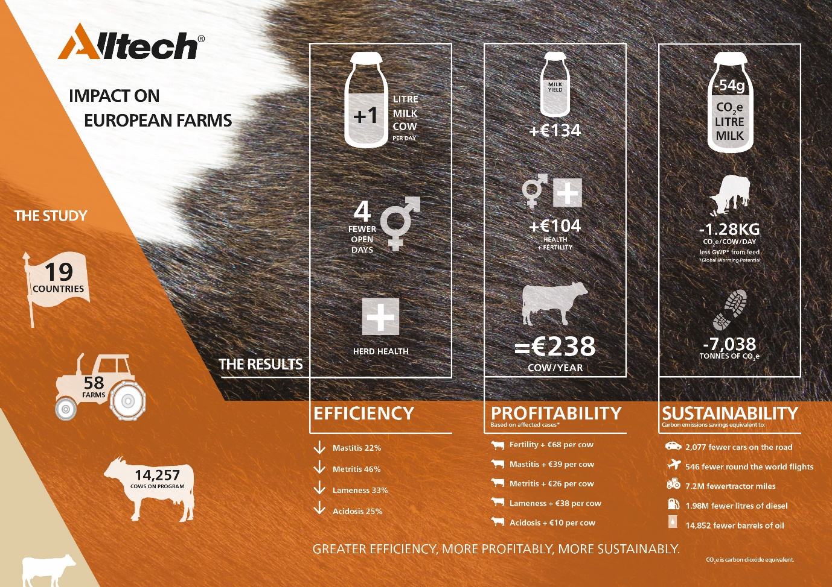

Climate Change Response (Zero Carbon) Amendment Bill: http://www.legislation.govt.nz/bill/government/2019/0136/latest/LMS183736.html.

